Digital Accessibility Tips

Headings and Structure
- Clear Title: Every document, PowerPoint, web page, etc. contains a clear title.
- Structure: Utilize heading, bullet points, lists, and paragraphs to maintain structure throughout the email, document, or web page.
  - Example:
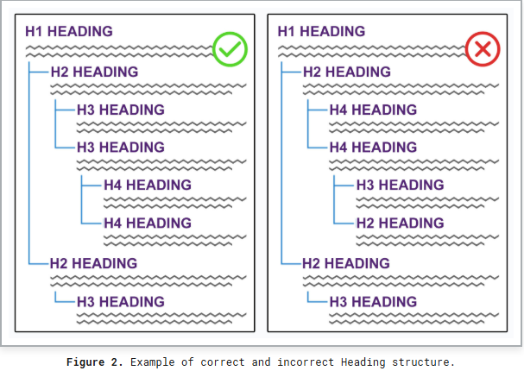
- Resources:
  - Tulane Headings in Drupal and Best Practices
  - Tulane Web Accessibility Best Practices
  - WCAG Headings
  - Section 508 – Document Headings

Meaningful Hyperlinks
- Use Specific Destination: When linking to a webpage, document, video, or other content, always include a specific destination, rather than “click here.”
  - Example: To report an accessibility barrier, please submit a report via the Campus Reporting Form.
- Resources:
  - WCAG Blog – Master the Art of Accessible Link Text
  - Section 508 – Descriptive Links and Hypertext

Videos and Images
- Captions: Every pre-recorded video or audio content, no matter where located, should have captions. Ideally, a transcript also accompanies a video or audio content.
- Alternate Text: When utilizing an image in an email, newsletter, webpage, PDF or elsewhere, provide alternate text – a brief description of the image – beneath the picture.
  - Example:

A student walks on a sidewalk at Tulane University, illuminated by sunlight filtering through the trees.
- Resources:
  - Tulane Email Accessibility Best Practices
  - Tulane Digital Accessibility: Characteristics
  - Web Accessibility Initiatives – Captions/Subtitles
  - Web AIM – Alternative Text

Font and Color
- Font: All font in communications, emails, newsletters, etc. should be at least 12-point and in a Sans Serif Font (e.g., Arial, Helvetica, Times New Roman, Tahoma, Verdana).
- Color: Utilize dark colors on light backgrounds, or light colors on dark backgrounds. Do not use color alone to emphasize – add bold or highlight.
- Resources:
  - Section 508 – Fonts
  - Siteimprove - Fonts
  - WCAG - Contrast

Write Simply
- Provide Definitions: Define acronyms and avoid jargon.
- Utilize Plain Language: Employ the following principles – from the National Archives Principles – in all types of writing:
  - Write for your reader, not yourself.
  - Use pronouns when you can.
  - State your major point(s) first before going into details.
  - Stick to your topic.
  - Limit each paragraph to one idea and keep it short.
  - Write in active voice. Use the passive voice only in rare cases.
  - Use short sentences as much as possible.
  - Use everyday words. If you must use technical terms, explain them on the first reference.
  - Omit unneeded words.
  - Keep the subject and verb close together.
  - Use headings, lists, and tables to make reading easier.
  - Proofread your work, and have a colleague proof it as well.

